Mini Dry Bath Incubator—MiniBox
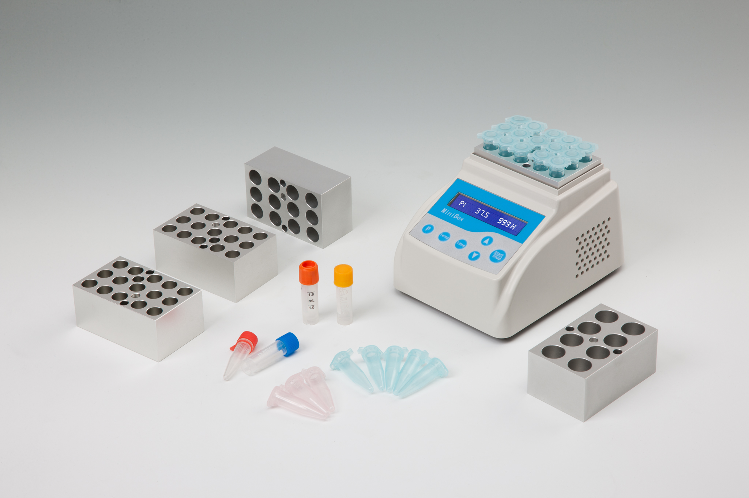
Description:
Minibox is a microprocessor-controlled product. It is widely used in preservation and reactions of sample, DNA amplification and initial denaturation of electrophoresis and so forth. It fits almost anywhere and can even be used in cars, boats or wherever a 24 volt power source is available.

Features:
- Energy-efficient design.
- Applicable to 24V power adapter.
- Accurate to ± 0.3℃.
- Process of experiment is visible.
- Electronic calibration. User can reset to any local standard.
- Power supply provided is UL, CSA and CE approved.
- Custom blocks made to fit any sample holder.

Parameters:
Type  Parameters | Minibox
Temp. range | RT.+5℃~100℃
Temp. accuracy | ≤±0.3℃
Time range | 1min~99h
Temp. uniformity | ≤±0.3℃
Display accuracy | 0.1℃
Temp. stability | ±0.3℃
Heating time | ≤20min(from 40℃ to 100℃ )
Voltage | DC24V/1.67A
Dimension(mm) | 145×113×110
Weight(kg) | 0.5

Optional Blocks:
Type Description
MiniBoxA 15×2.0ml
MiniBoxB 15×1.5ml
MiniBoxC 24×0.5ml
MiniBoxD 32×0.2ml (for 0.2ml PCR 8-tube strip)
MiniBoxF 32×0.2ml (for 0.2ml Elisa 8-well strip)

